Abingdon School
Summer Reading Challenge 2023
Are you looking for a great new summer read? Or are you stuck in a reading rut, not enjoying books as much as you used to? Or have you never quite found a novel you really liked? Whatever the case, help is at hand!

One of the main reasons for being stuck in a reading rut is sticking to stuff you know. So, this summer, we challenge you to challenge yourself.

Read up to 8 new books across 8 literary genres – that’s a book a week in every week of the holidays!

To get started, take a look at the list of genres below and the list of ‘Books worth second looks.’ But these are only a start; you can read other books, in other genres, as well.

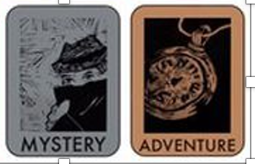
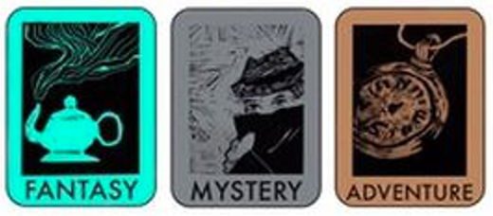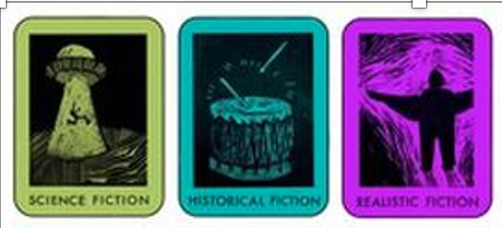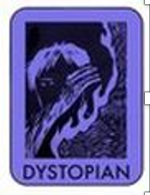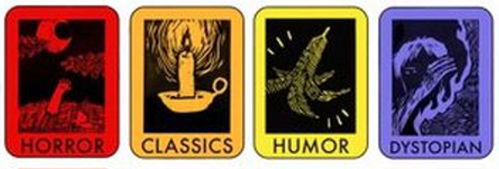

We’re offering an edible prize (chocolate!) for anyone who manages to read between 4 and 8 books – that’s between 1 book a week and 1 book a fortnight. The most widely read pupil in each year group will win the GRAND PRIZE!

To claim your prize, read your books and complete the reading record on the next page. Submit this to your English teacher as a hard copy or by email (subject line: ‘Reading Challenge’; copy in a parent) by Friday 8th September.

Happy reading, and best wishes for the summer!
The English Department & The Library

Date | Book title and author | Genre | Your verdict on the book | Parent’s signature
Summer Reading Challenge 2023: Reading Record

